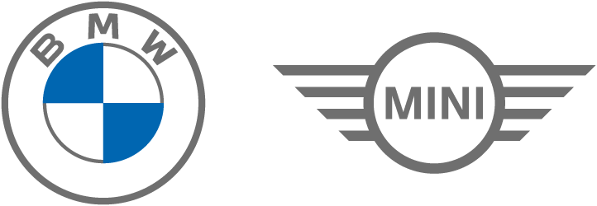
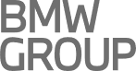
Financial Services
Payment Methods
- Direct Debit Authorization (DDA)
- Authorization by providing bank details to Customer Care of BMW / MINI Financial Services at 2598 1009, 9am-5pm Monday to Friday. Authorization confirmation email will be provided
- Ensure sufficient funds in your bank account (at least 2 working days before the payment date)
- If the payment date falls on a weekend or public holiday, the direct debit will be processed on the next business day
- Faster Payment System (FPS)
- Please ensure the Daily Payment Limit of your FPS account is not lower than the Monthly Rental Payment
- For Payee, choose FPS Identifier. Enter our FPS Identifier: 166563965
- Indicate your agreement number or vehicle registration number in “Message” section as payment record

- PPS
- Please complete transaction 3 working days before the payment date to avoid delay payment and late charges.
- For instructions how to register with PPS, please refer to http://www.ppshk.com
Merchant code (4-digit): | 9160
Bill account number (10-digit): | [pps no] (only applicable to this agreement)
Payment amount: | Monthly Rental Payment
Bill: | Citibank Merchant Collection Services
Bill type: | 05 (Others)
Cut off time: | Monday to Friday before 7pm (except public holiday)
Max transaction amount: | Please refer to your bank

- Automated Teller Machine (ATM)
- Transfer or deposit cash or cheque over a HSBC / Hang Seng Bank ATM / Branch in Hong Kong
Bank name: | The Hongkong and Shanghai Banking Corporation Limited
Account name: | BMW Financial Services Hong Kong Limited
Account number: | 004 (Bank No)-741 (Branch No)-139562001 (Account)
- Please indicate your agreement number or vehicle registration number in the receipt and email us to recognize your payment

- Internet Banking
- Please email transfer confirmation to customerservicehk@bmw.com to recognize your payment with email subject: “Rental Payment Proof for [your agreement number / vehicle registration number]”
- Service charge by your bank may occur

- Cheque
- If you will issue cheque, please bank in 3 working days before the payment date as per details of “4. Automated Teller Machine (ATM)” above. Otherwise, please add HK$50 being handling fee to the instalment amount and mail the cheque to our postal address at least 5 working days before the payment day to avoid delay payment
Postal address: Rm E, 1/F, Sime Darby House, 380 Castle Peak Road, Tsuen Wan, N.T., Hong Kong
- Indicate your agreement number or vehicle registration number at the back of the cheque
- Cash or post-date cheque unaccepted
- Crossed cheque payable to: BMW Financial Services Hong Kong Limited
Financial Services

供款方式

- 自動轉帳
- 致電BMW/MINI Financial Services客戶服務2598 1009提供銀行資料授權自動轉賬 (星期一至星期五，早上九時至下午五時)，登記電郵將收到確認附件
- 請確保閣下的銀行戶口於供款日前2個工作天，有足夠款項
- 如供款日為星期六丶星期日或至公眾假期，自動轉帳將於下一個工作日執行
- 轉數快 FPS
- 轉帳前請確保閣下銀行轉數快賬戶的每日轉賬限額不低於每月供款額
- 收款賬戶選擇 “快速支付系統識別碼”，然後輸入本公司識別碼：166563965
- 請在 “備注” 列明閣下的協議編號或車牌號碼作為供款記錄

- 繳費靈 PPS
- 請於供款日前3個工作天完成繳付，以免產生逾期費用
- 設立繳費靈戶口，請參閱繳費靈網頁 http://www.ppshk.com
商戶編號 (4位數字): | 9160
賬戶號碼 (10位數字): | [pps no] (只適用於本協議)
賬單金額: | 每月供款額
賬單: | 花旗商戶託收服務
賬單類別: | 05 (其他)
截數時間: | 星期一至星期五下午7時 (公眾假期除外)
最大交易金額: | 請向閣下的銀行查詢

- 自動櫃員機
- 可在本港任何一間滙豐/恒生自動櫃員機/分行，直接轉賬或現金或支票供款
- 請將閣下的協議編號或車牌號碼寫在收據上並電郵給我們以作為供款記錄
銀行名稱: | 香港上海滙豐銀行有限公司
賬户名稱: | BMW Financial Services Hong Kong Limited
賬户號碼: | 004 (銀行編號)-741 (分行編號)-139562001 (賬户)

- 網上銀行
- 請以“[閣下的協議編號或車牌號碼]供款記錄”為標題電郵轉賬交易證明至customerservicehk@bmw.com作為供款記錄
- 閣下的銀行可能收取相關費用

- 支票
- 若閣下以支票繳付，請按照“4.自動櫃員機”信息準備支票，並於供款日前3個工作天入票。否則，請在供款額加港幣$50手續費，於供款日前5個工作天寄回本公司以免延誤
郵寄地址：荃灣青山公路荃灣段380號1樓E室
- 請在支票背後列明閣下的協議編號或車牌號碼作為供款記錄
- 恕不接受現金或期票
- 劃線支票抬頭：BMW Financial Services Hong Kong Limited

